BeanSquad primarily bills merchants on flat monthly fees based on annual contracts, with some ad hoc service work billed separately.

* BTs can be found in the Scope of Work Section (screenshot below)

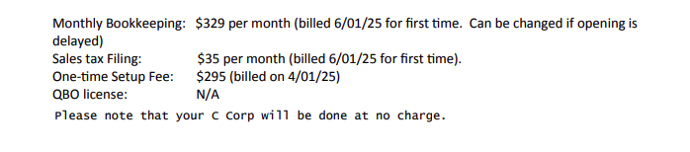

* The BTs for a standard contract will primarily consist of only a one-time set-up fee, a monthly bookkeeping fee and a late fee. Additional BTs will be specified. For example, sales tax filing in the screenshot.
  + Service start date: effective date

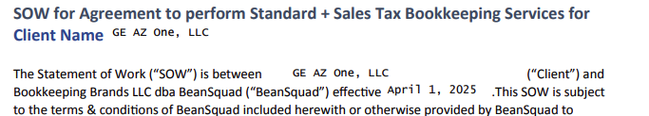

* Total months of service: found in Term section
  + Will usually be 12 months

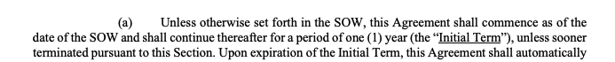

* Billing start date: explicitly listed for each billing term (“billed 6/01/25 for first time”)
  + If not listed, use the effective date
* # of periods and frequency
  + For one-time setup this will be None
  + Everything else will state the frequency
    - Use # of periods to cover the term length
* Net terms will most often be listed in “Fees and Expenses; Payment Terms; Interest on Late Payments” section.
  + If not available, search the document for any associated keywords.
  + If no payment terms listed, default to 30
* Item names are listed
* Most contracts will have late fees, if so please process as a % of the event Past Due Amount
  + Most will be monthly over the contract term
* Can ignore any N/A, waived or free BTs